Sienna Ballot (16881771)

Hayden Yu (66185399)

EECS 118

Team 61

12 December 2019

Graph Peer Review

Reviewing team 4’s Problem 31: find s where is_path(s) and max_degree(s, t, G) and color(s, Color, u) and t<C and u<D

Test Plan:

The program will be tested with two different graphs and inputs.

Graph #1:

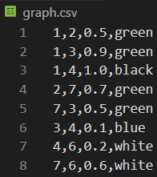

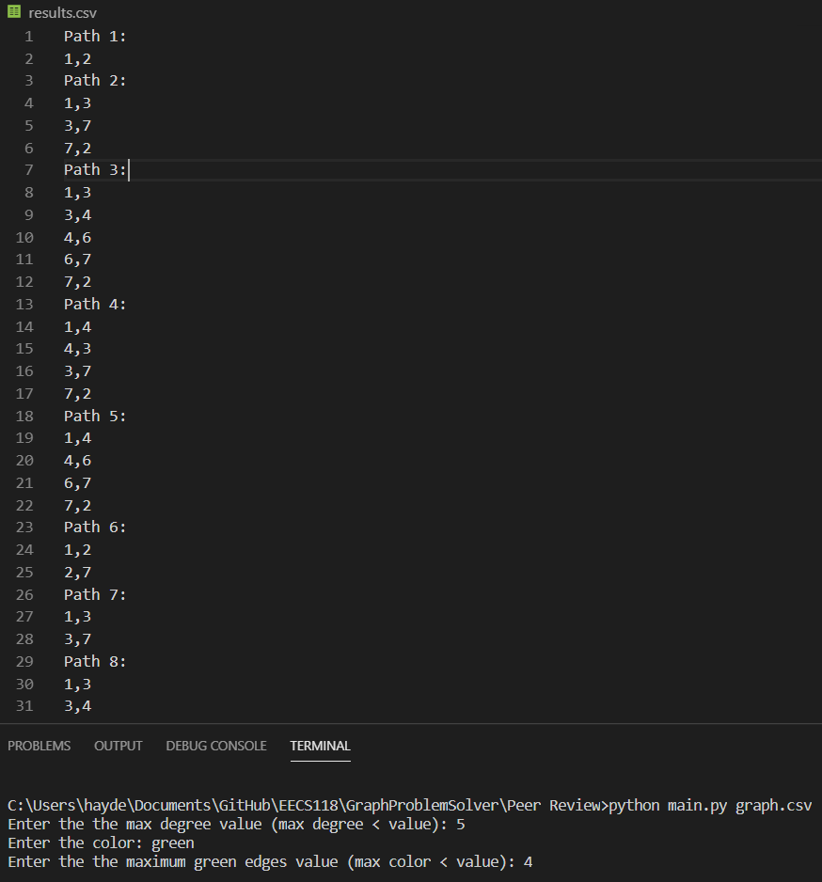

Testcase 1, C = 5, Color = Green, D = 4: The program produced over a hundred paths.

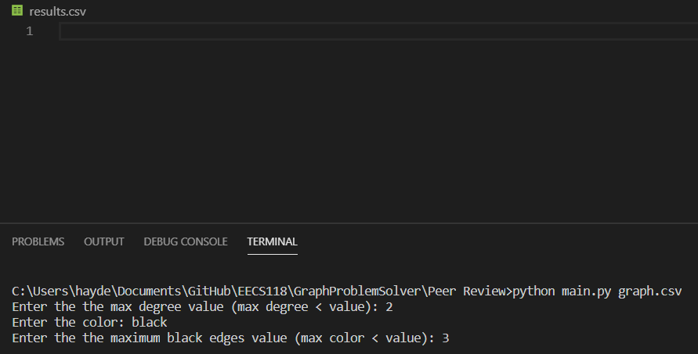

Testcase 2, C = 2, Color = Black, D = 3: The program didn’t output anything which is correct

Graph #2:

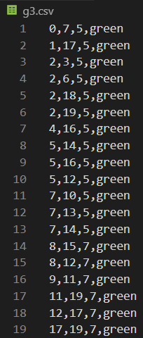

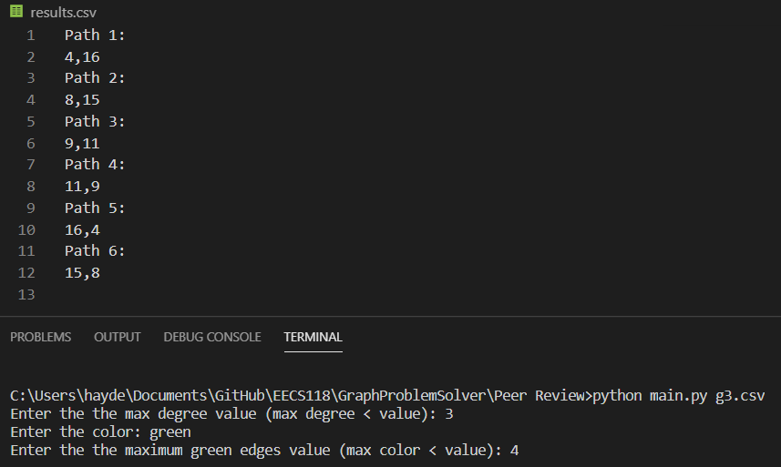

Testcase 3, C = 3, Color = green, D = 4: The program outputted correct paths but it’s missing path 8,12.

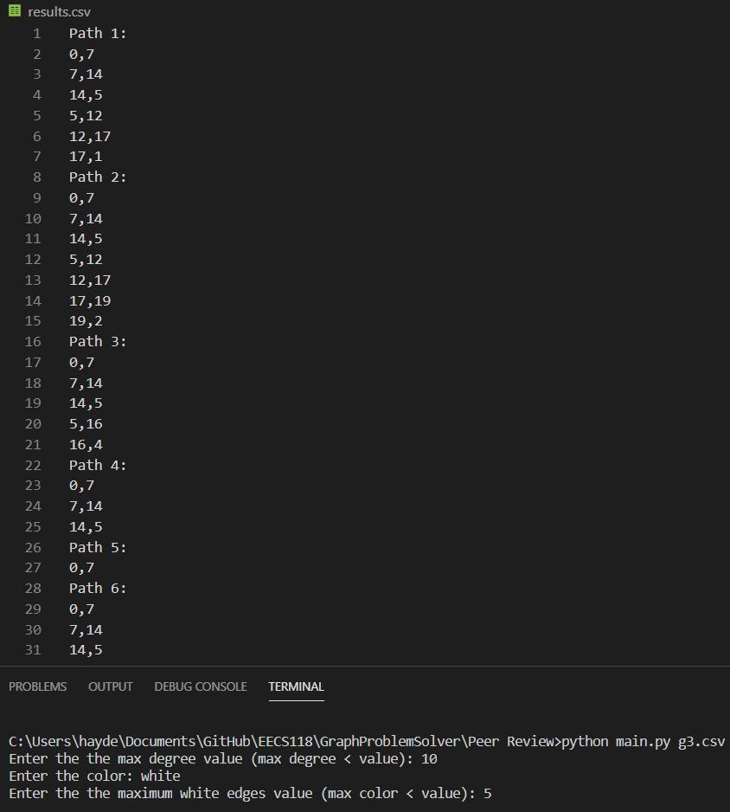

Testcase 4, C = 10, Color = White, D = 5: The program outputted values but it shouldn’t have because the graph doesn’t have any white paths.